Doctor Patient Portal

In this project as per your requirements we have developed 3 modules

1. Admin module: admin can login to system by using username and password as ‘admin’ and ‘admin’. After login admin can add Doctor Details and give login data to doctor. Admin can view doctor details, appointments, organ donor details, feedback and patient details
2. Patient Module: patient can signup with the application and then login to application. Patient can view their own details, book and cancel appointments, view appointments, donate or search organs and can give feedback
3. Doctor Module: doctor can login to system by using login details given by admin and then can view won profile, view appointments and generate prescription.

Each doctor will work in 3 hours slot and in 3 hour 6 patients can be taken and after 6 appointments system will display ‘Already Booked’ message.

To run code follow below steps

Install python 3.7.0 and then open command prompt and install packages using below commands

pip install PyMySQL==0.9.3

pip installDjango==2.1.7

Now double click on ‘runServer.bat’ to start DJANGO server and get below screen

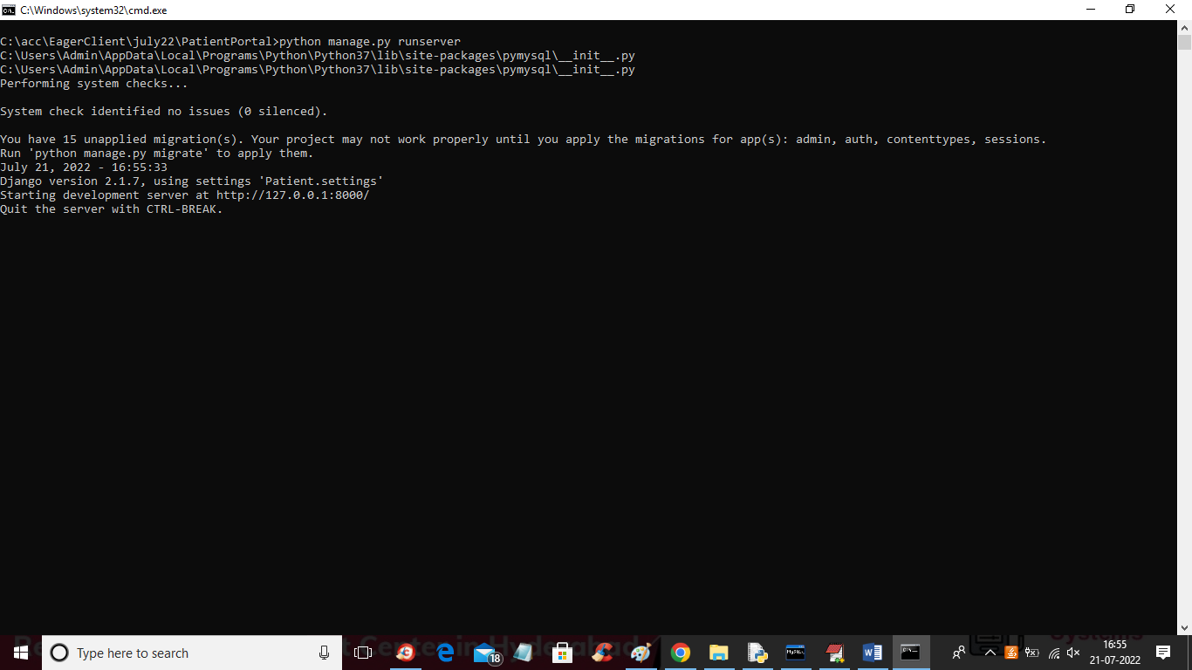

In above screen server is started and now open browser and enter URL as ‘http://127.0.0.1:8000/index.html’ and press enter key to get below screen

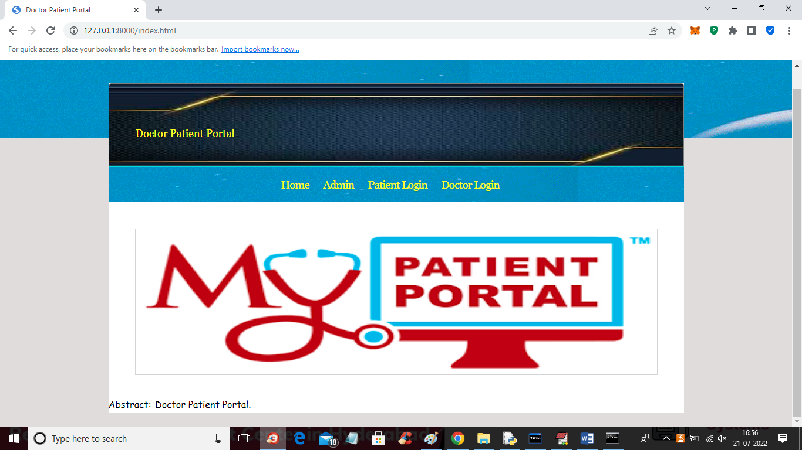

In above screen click on ‘Admin’ link to get below login screen

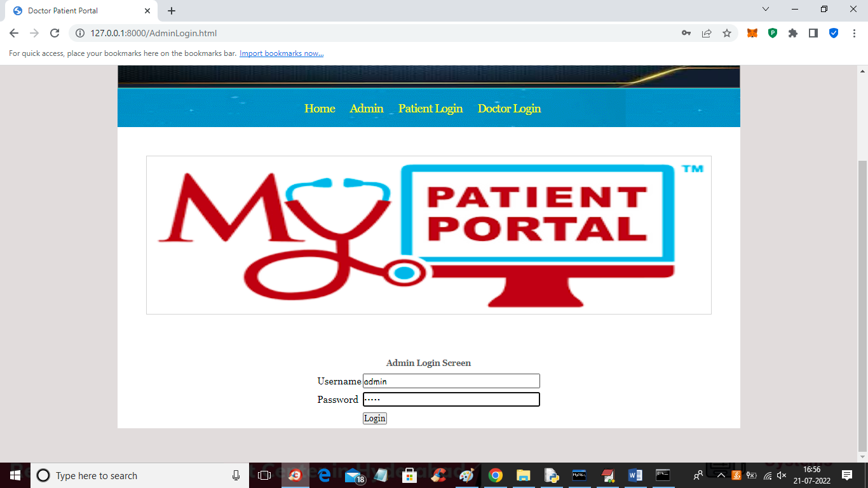

In above screen admin is login and after login will get below admin home screen

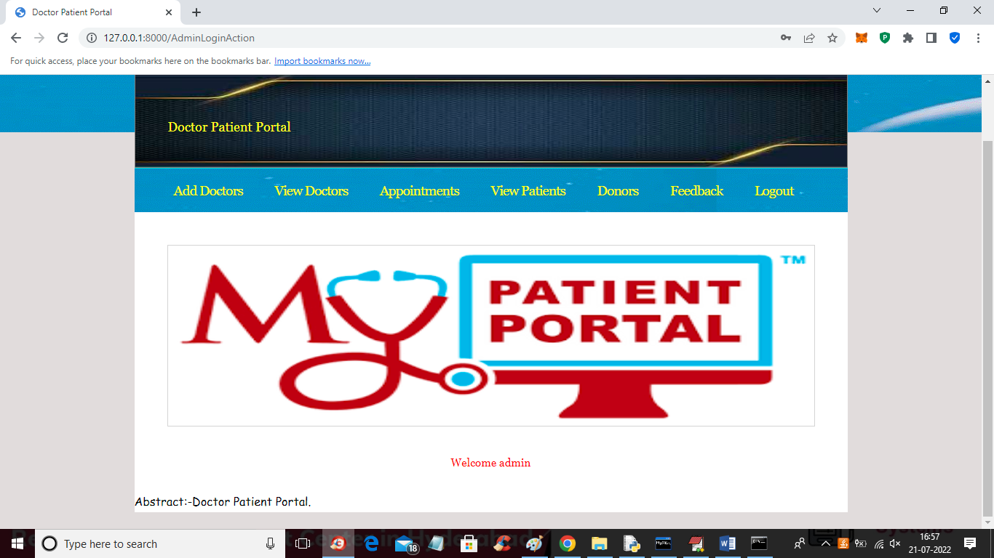

In above screen admin can click on ‘Add Doctor’ link to get below screen

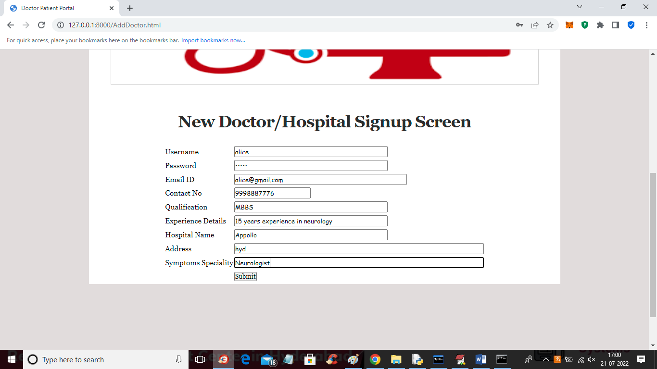

In above screen admin is adding doctor details and then press button to get below output

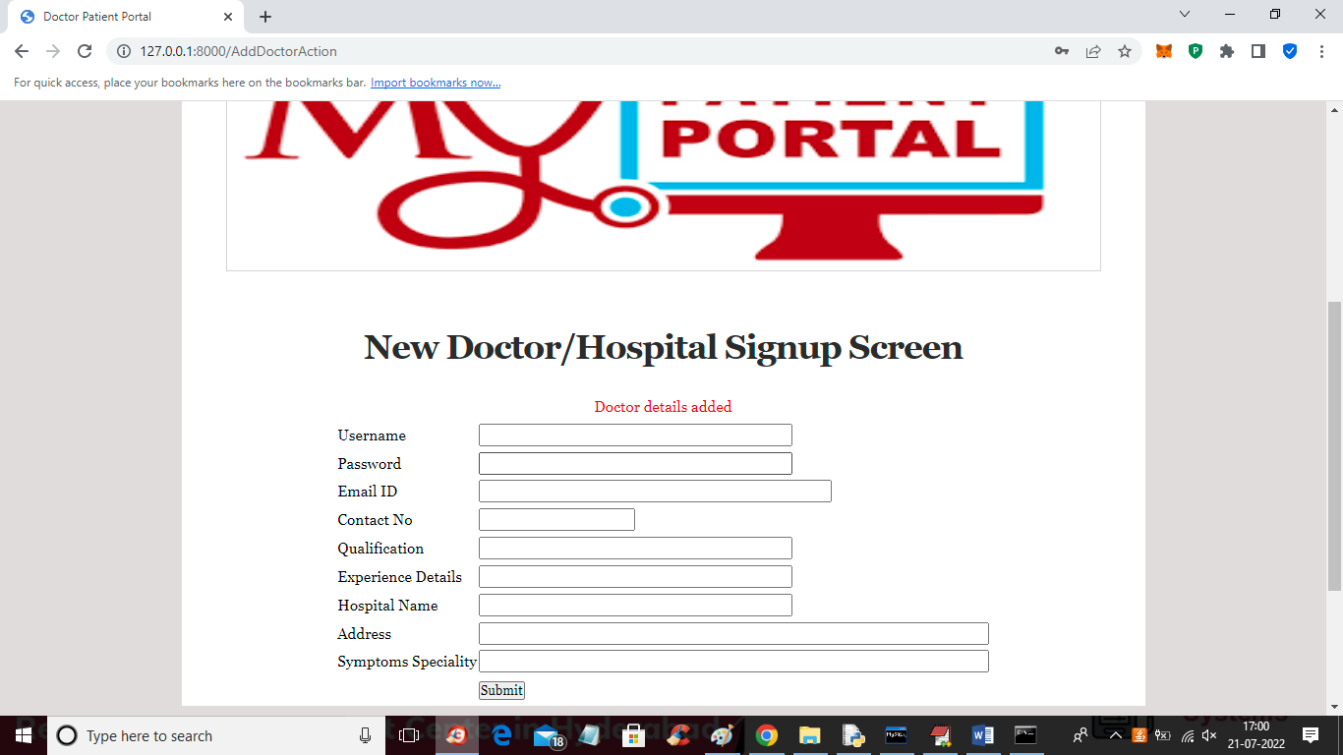

In above screen doctor details added and now admin can click on ‘View Doctors’ link to view all available doctor details

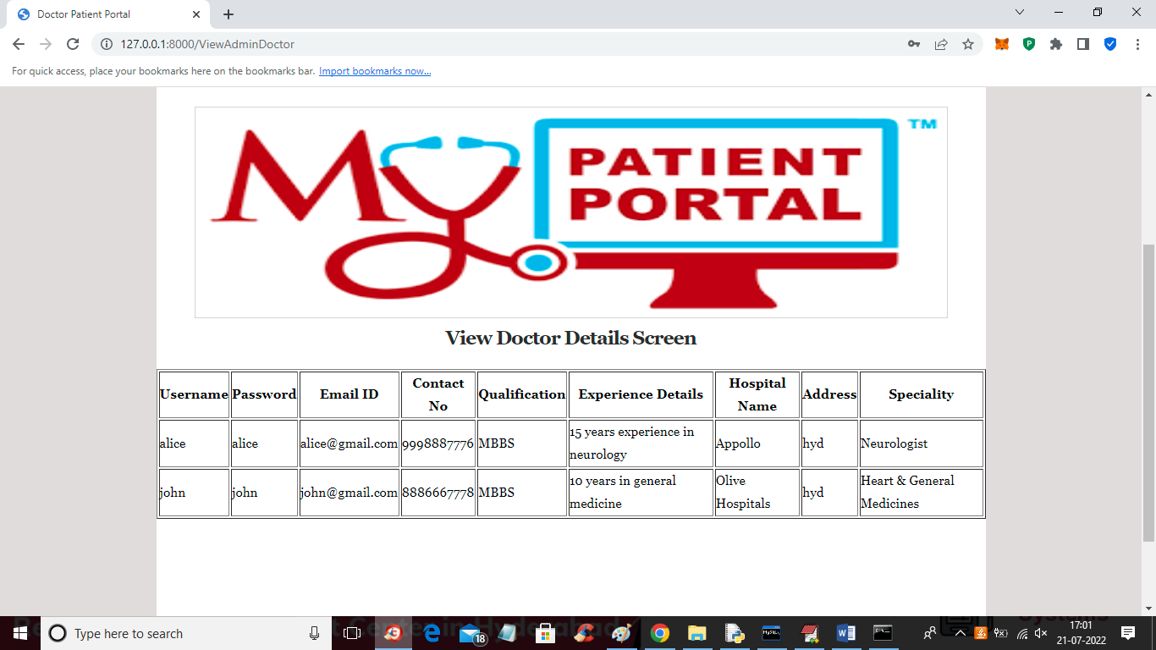

In above screen admin can see all doctor details and now click on ‘Appointments’ link to view all appointments

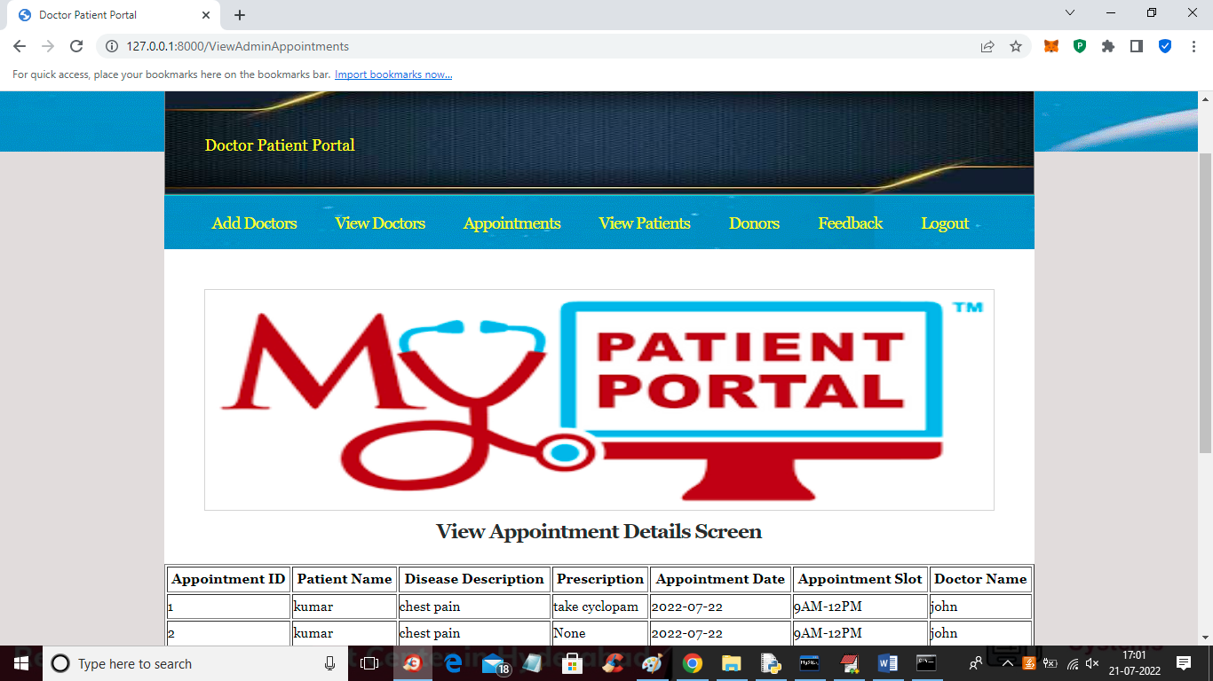

In above screen admin can see appintments details and if prescription not given by doctor yet then it will display message as ‘None’ else display given prescription. Now click on ‘View Patients’ link to view all patients details

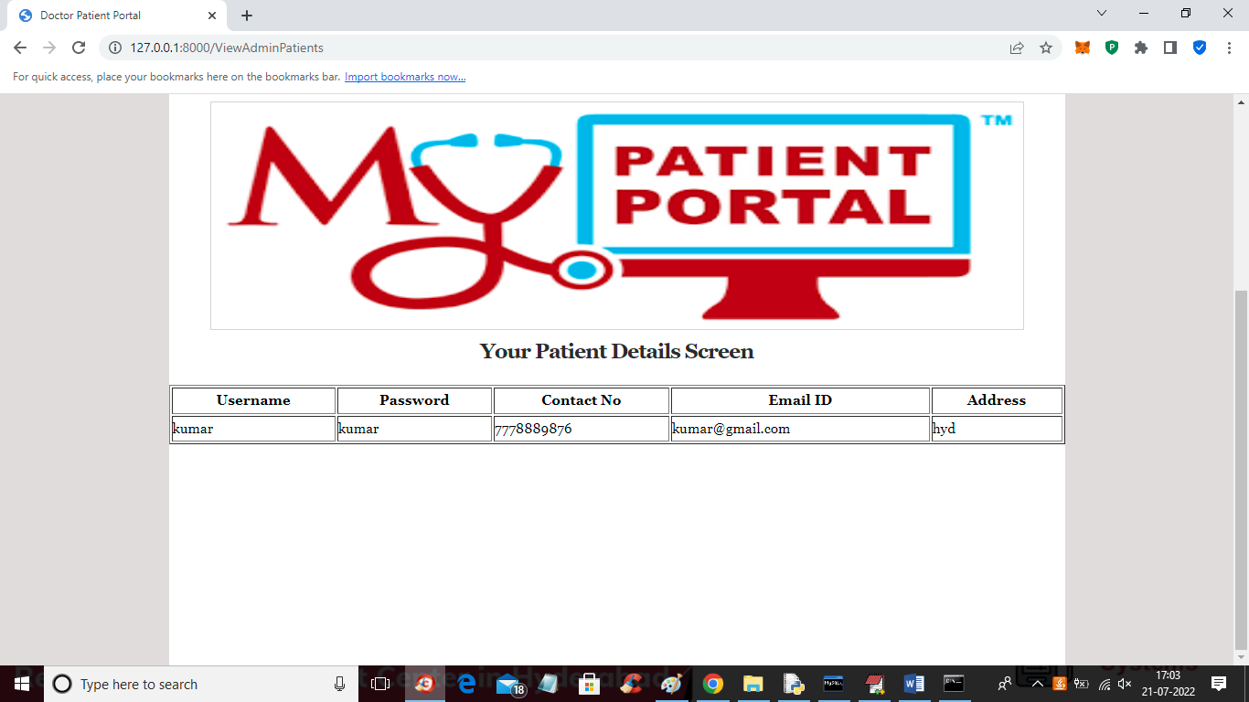

In above screen admin can view all patient details and now click on ‘Donor’ link to view donor details

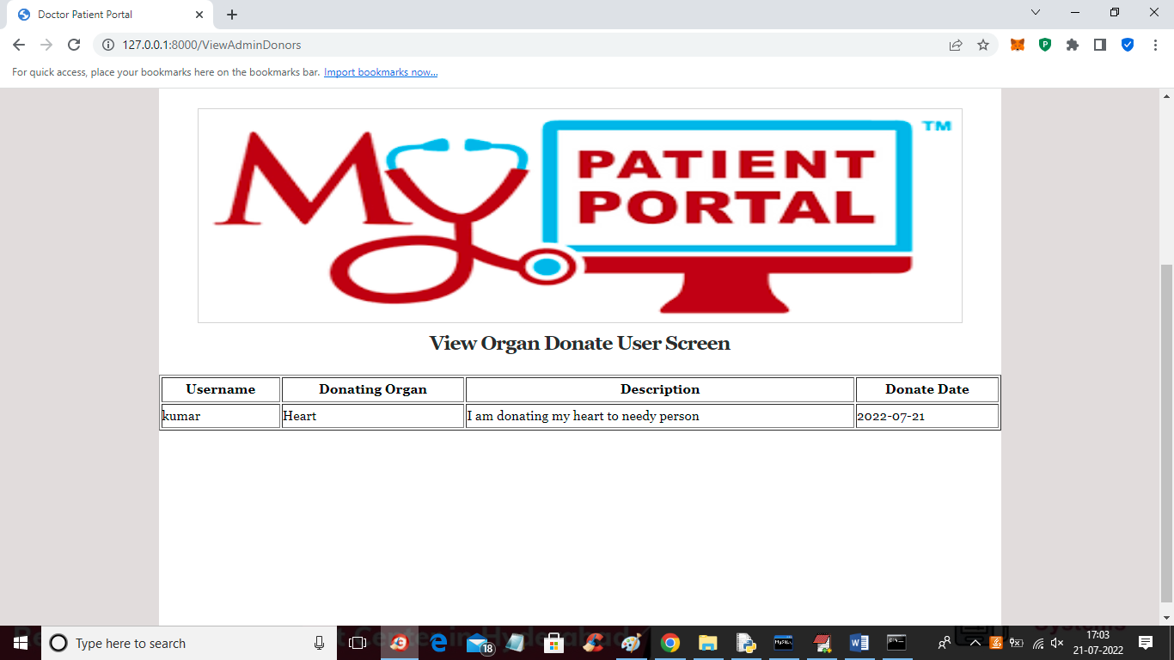

Now admin can click on ‘Feedback’ link to view feedback given by patients

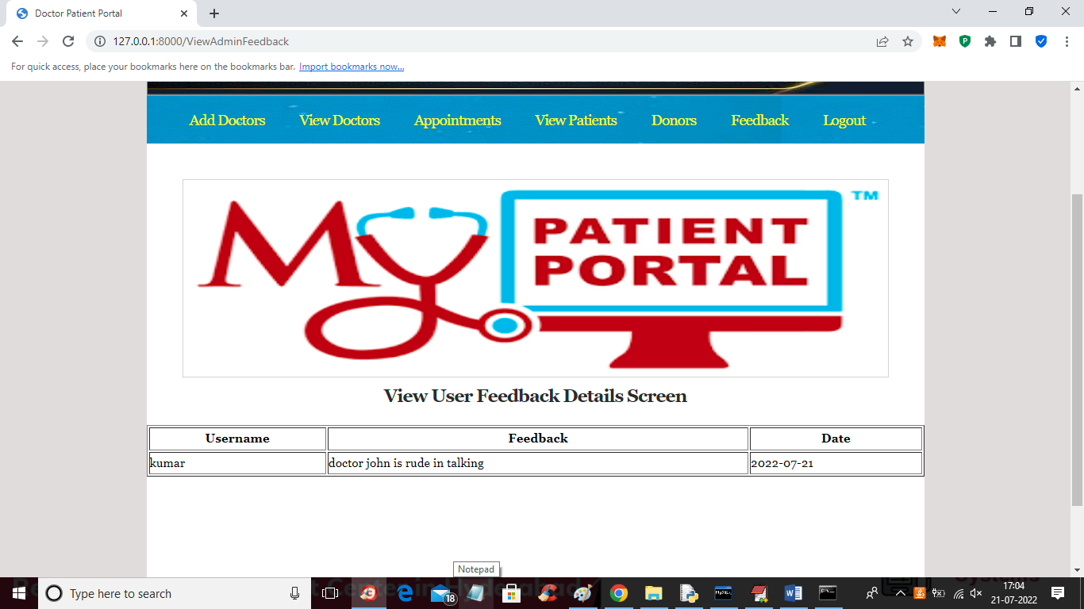

In above screen admin can view feedback from patients and now logout and login as patient

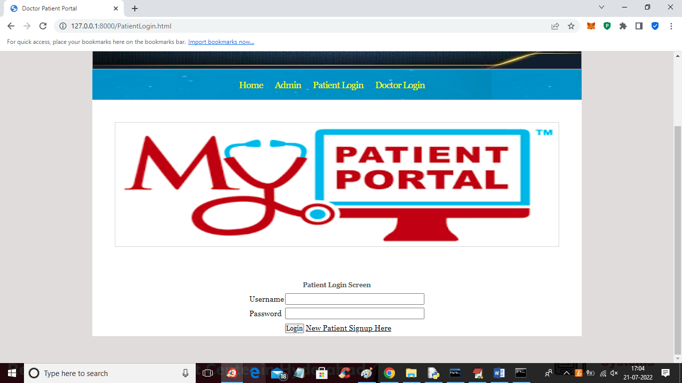

In above screen patient can click on ‘New Patient signup Here’ link to get below patient signup screen

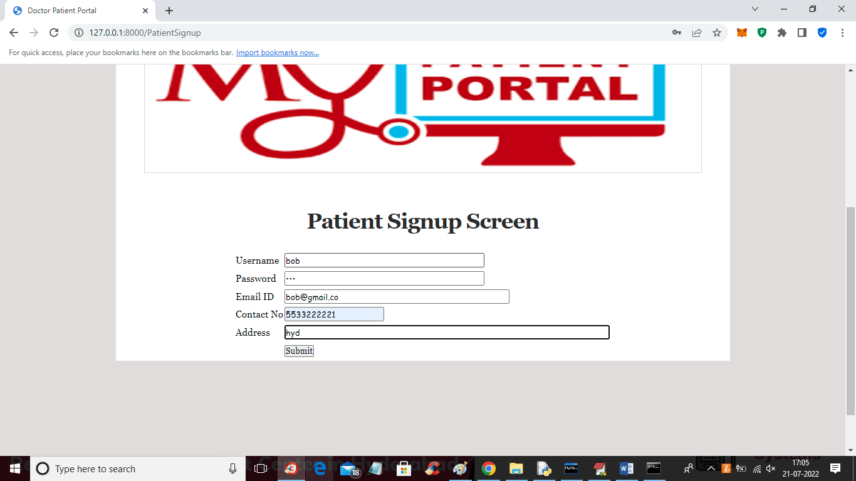

In above screen patient is signing up and then press button to get below output

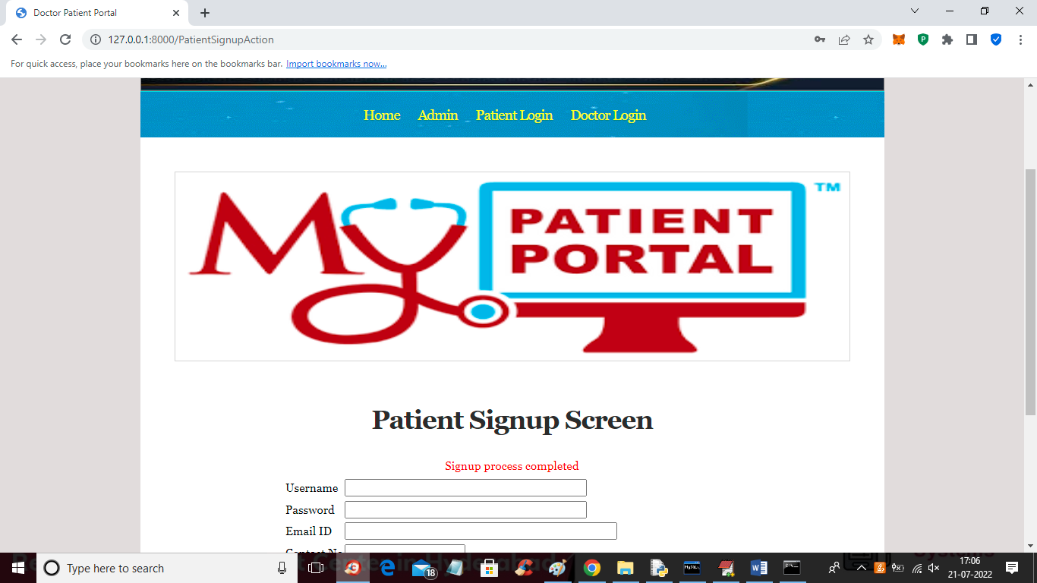

In above screen patient signup completed and now click on ‘Patient Login’ to login as patient

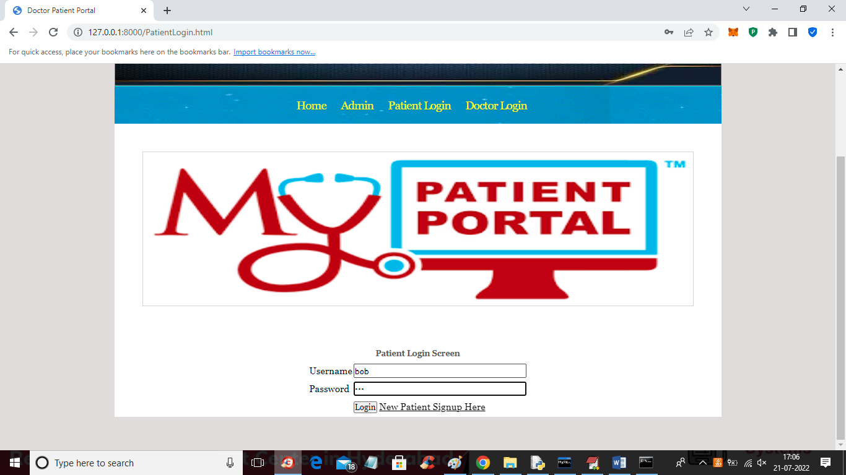

In above screen patient bob is login after login will get below patient home screen

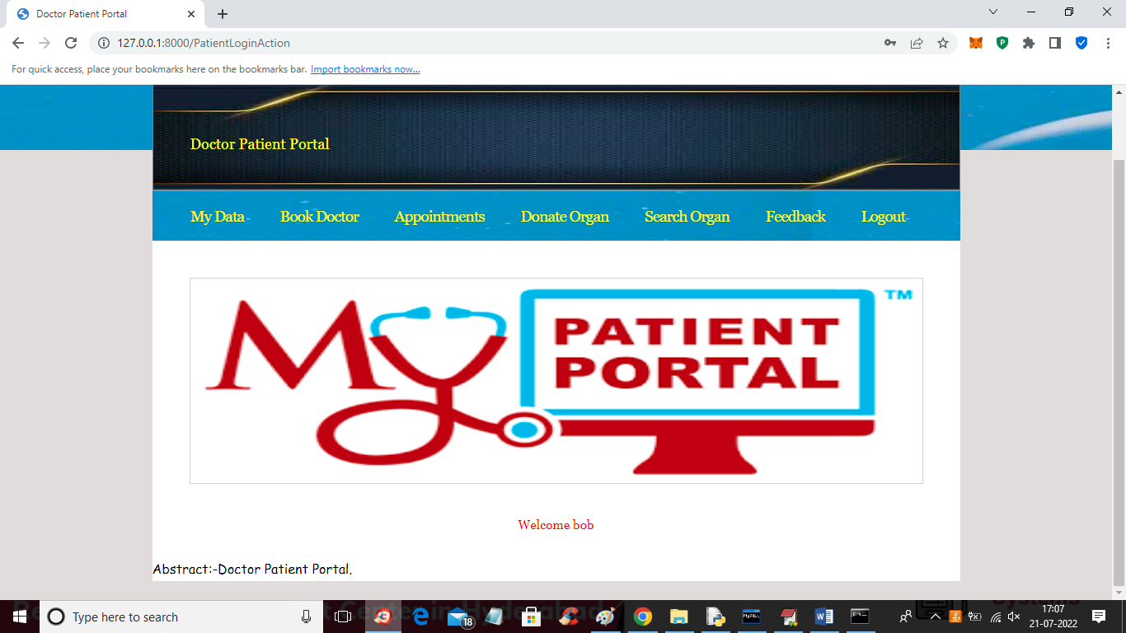

In above screen patient can click on ‘My Data’ link to view his profile like below screen

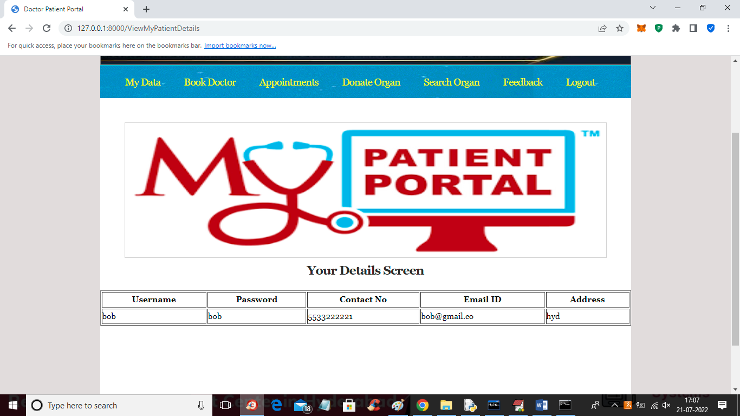

In above screen patient can view all his details and now click on ‘Book Doctor’ link to book appointment

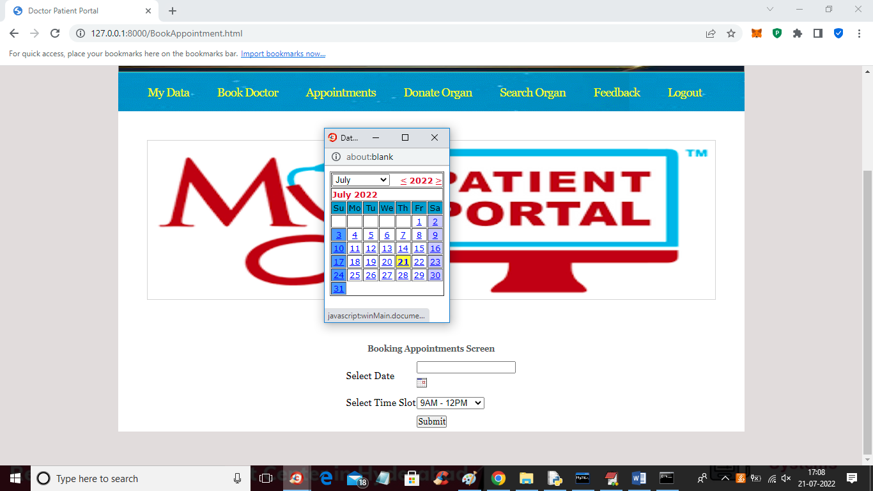

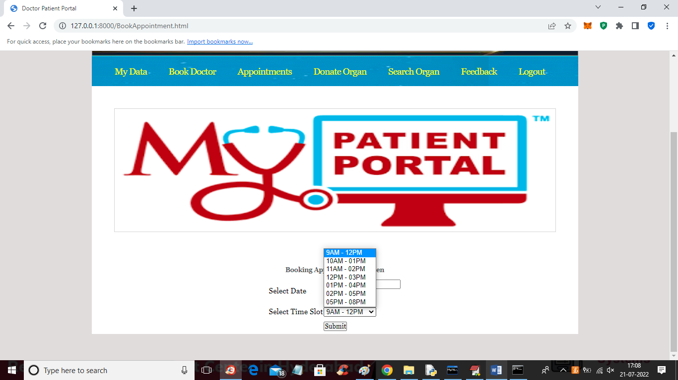

In above 22 screens first select date and then select SLOT and then press button to view all doctor’s availability

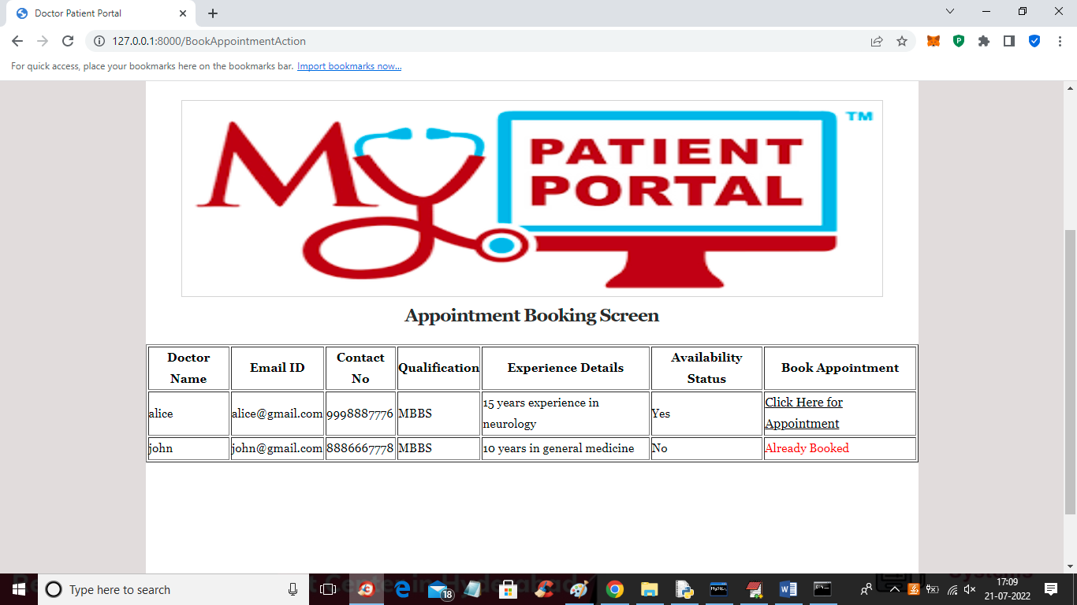

In above screen for doctor John there is no appointment available but alice is available so click on ‘Click Here for Appointment’ link to book appointment and get below screen

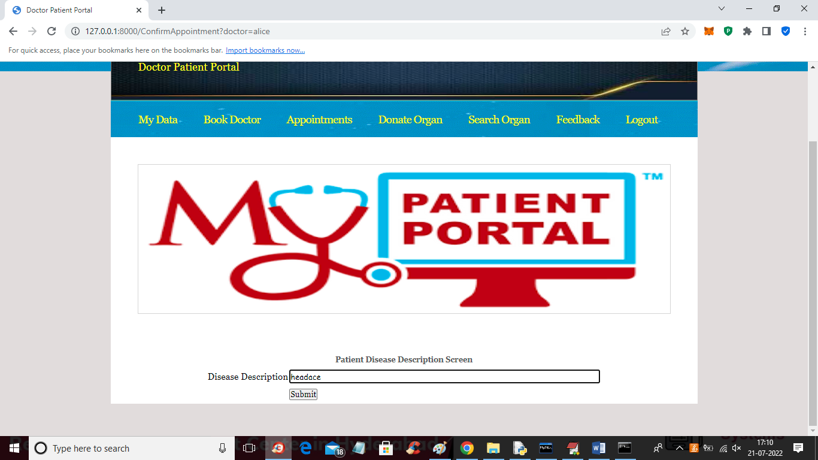

In above screen patient has to enter disease or symptoms details and then press button to confirm appointment and get below output

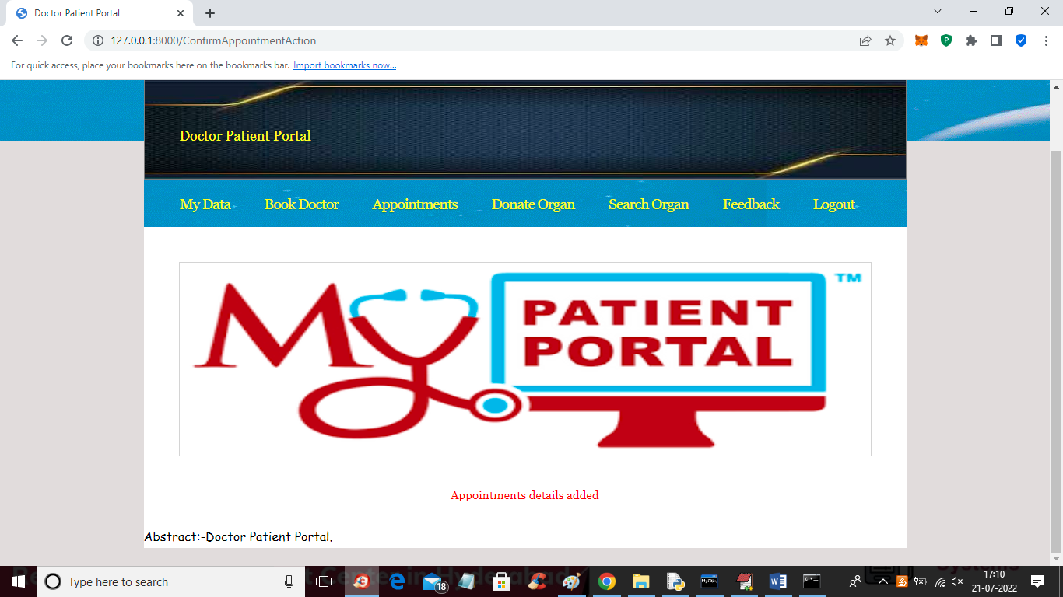

In above screen in red colour text we can see appointment details added and now click on ‘Appointments’ link to view all past appointments and get below output

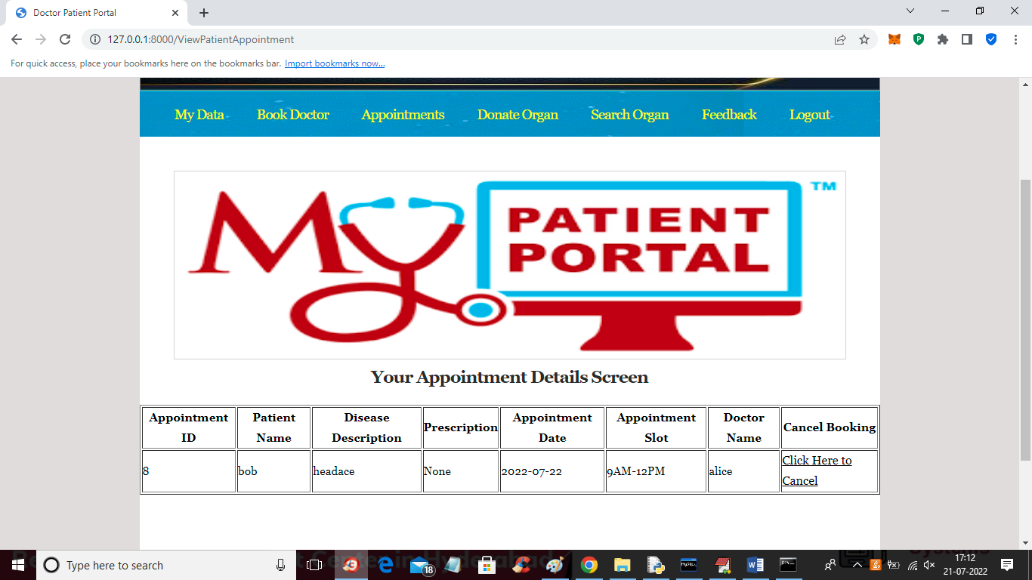

In above screen patient can view his appointments details and at any time before prescription generated patient can cancel appointment by clicking on ‘Click Here to Cancel’ and now click on ‘Donate Organ’ link to donate organ

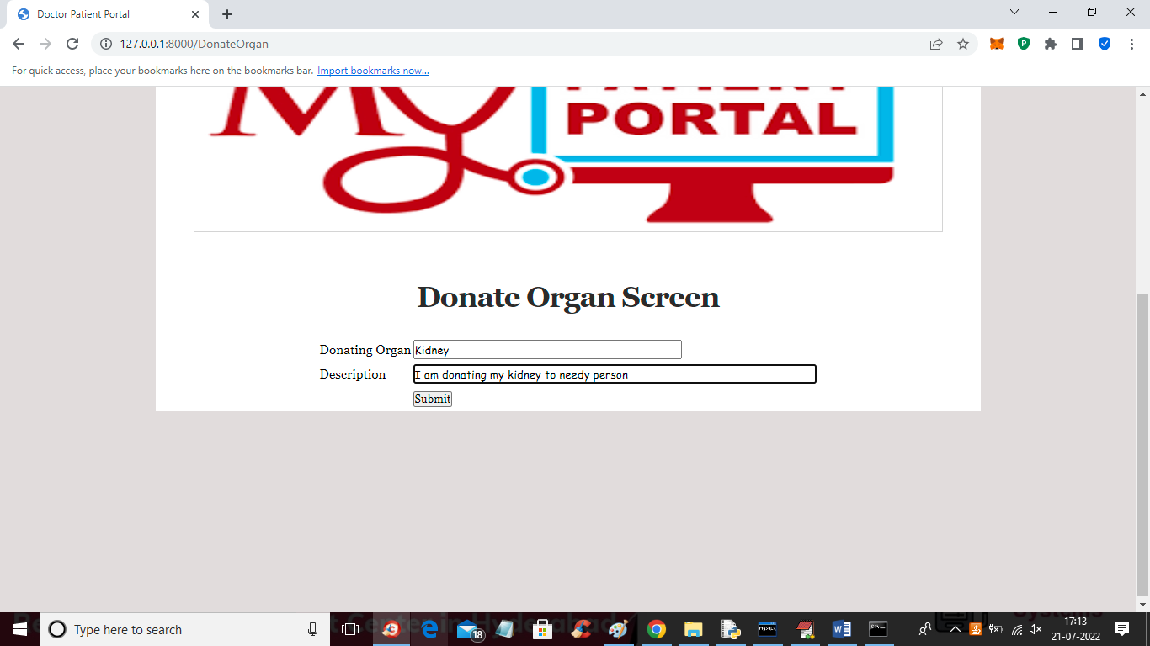

In above screen user can enter donating organ details and press button to add organ details and get below output

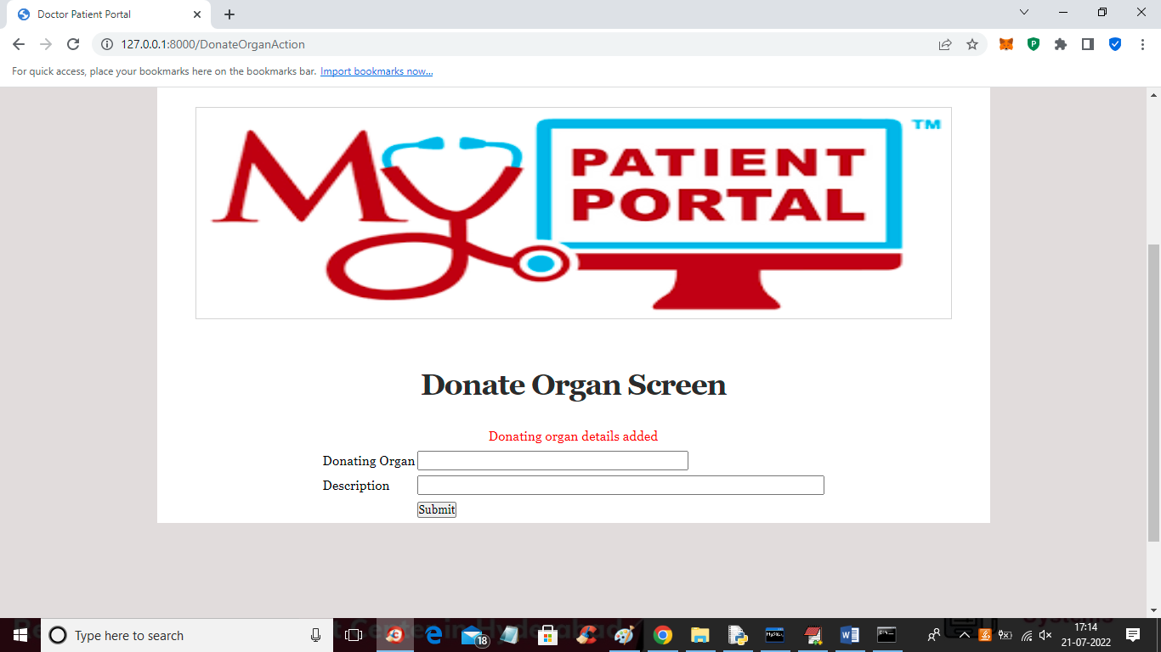

In above screen donation details added and now click on ‘Search Organ’ link to view all donors details

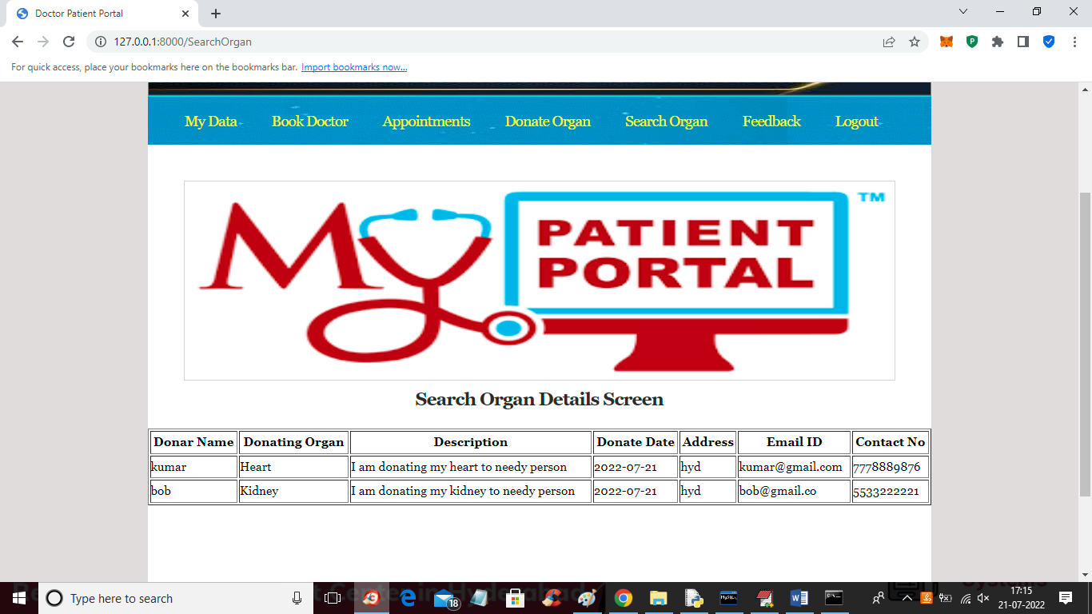

In above screen user can view all donor details with organ and contact information and now click on ‘Feedback’ link to add feedback details

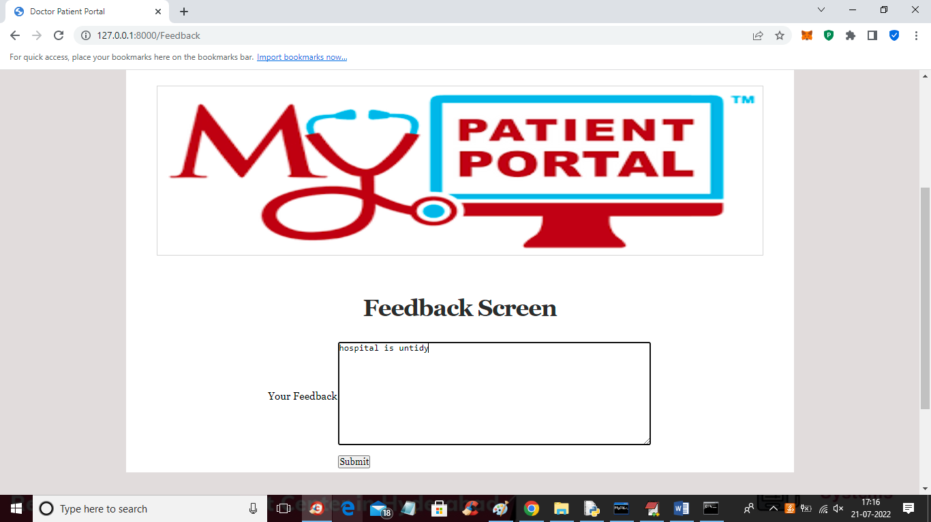

In above screen patient can give feedback and press button to send feedback to ADMIN

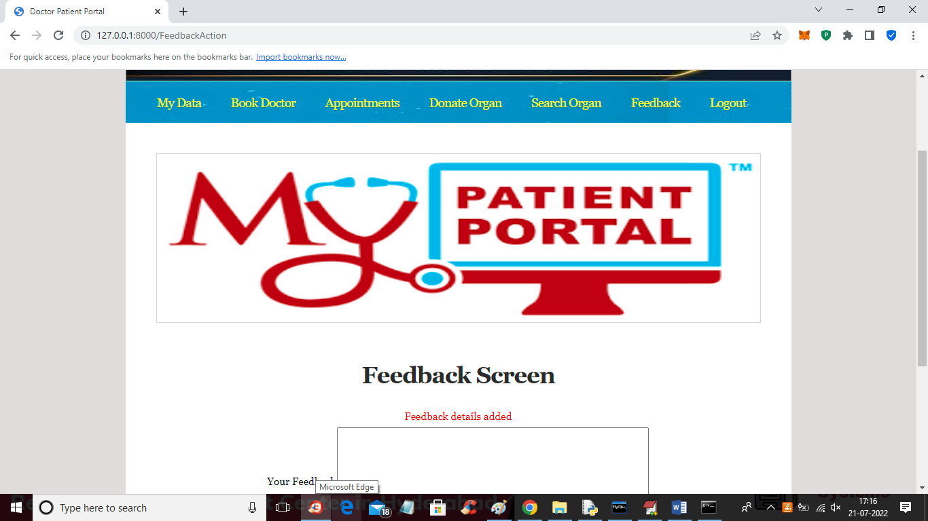

In above screen feedback details added and now logout and login as doctor to generate prescription

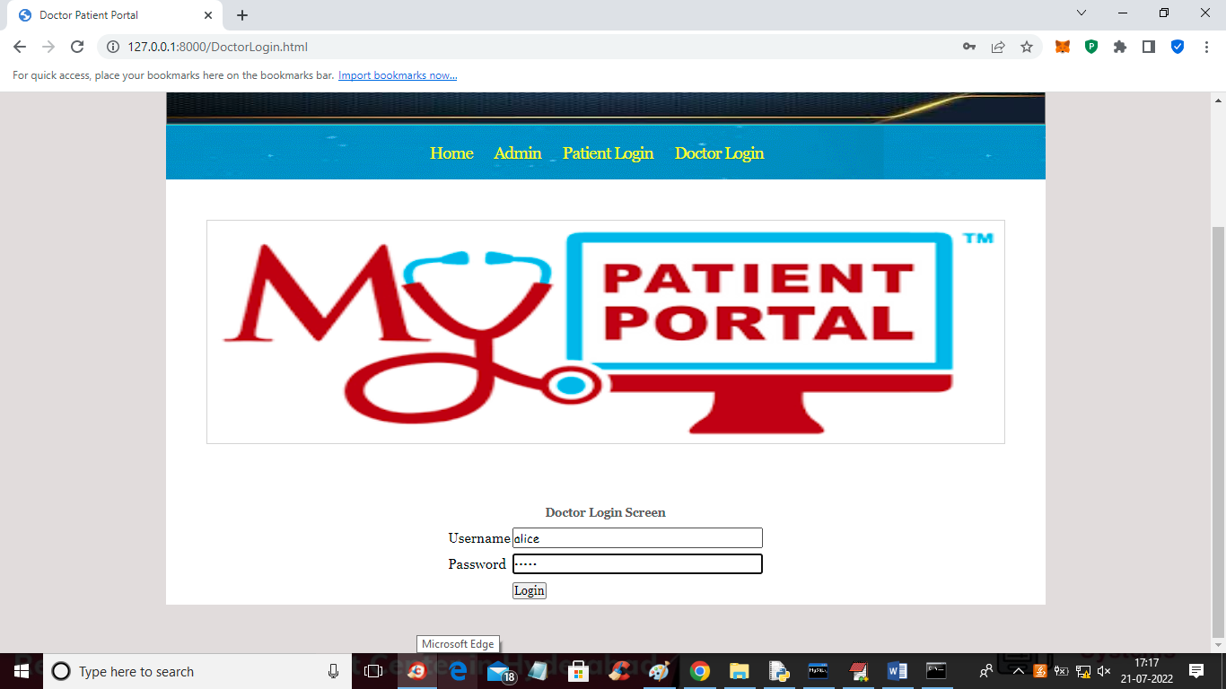

In above screen doctor is login and after login will get below doctor home page

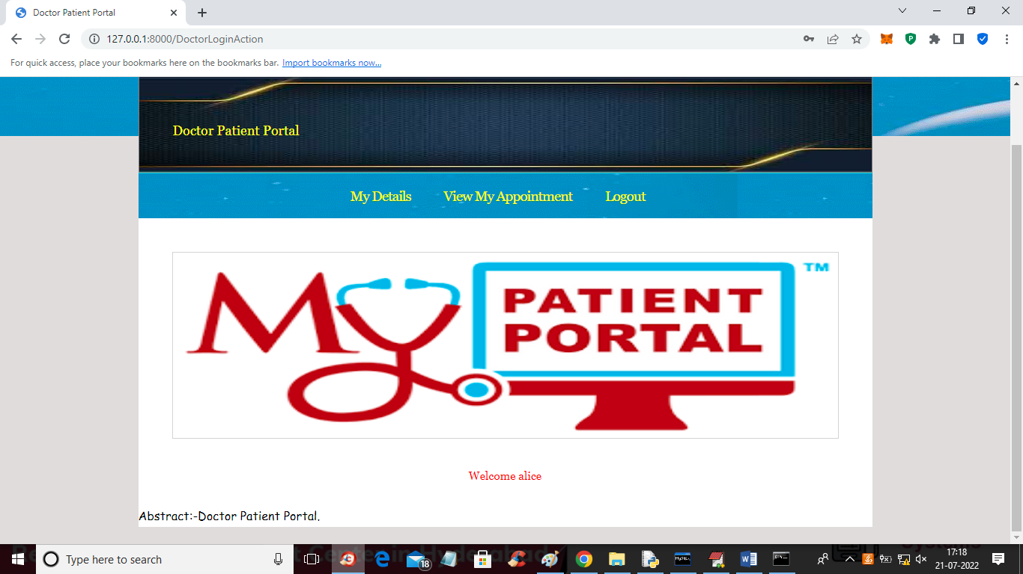

In above screen doctor can click on ‘My Data’ link to view his profile and get below output

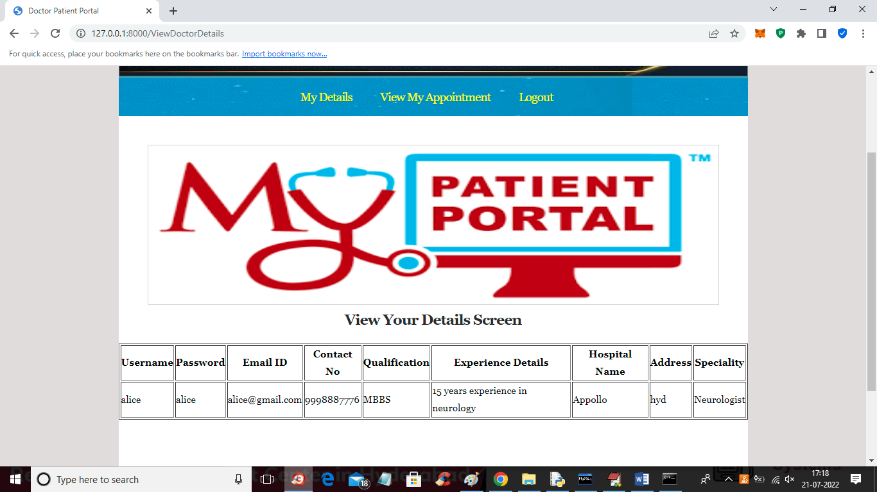

In above screen doctor can view his profile and now click on ‘View My Appointments’ link to get below screen (NOTE: doctor can view all those appointments which are available in today’s date)

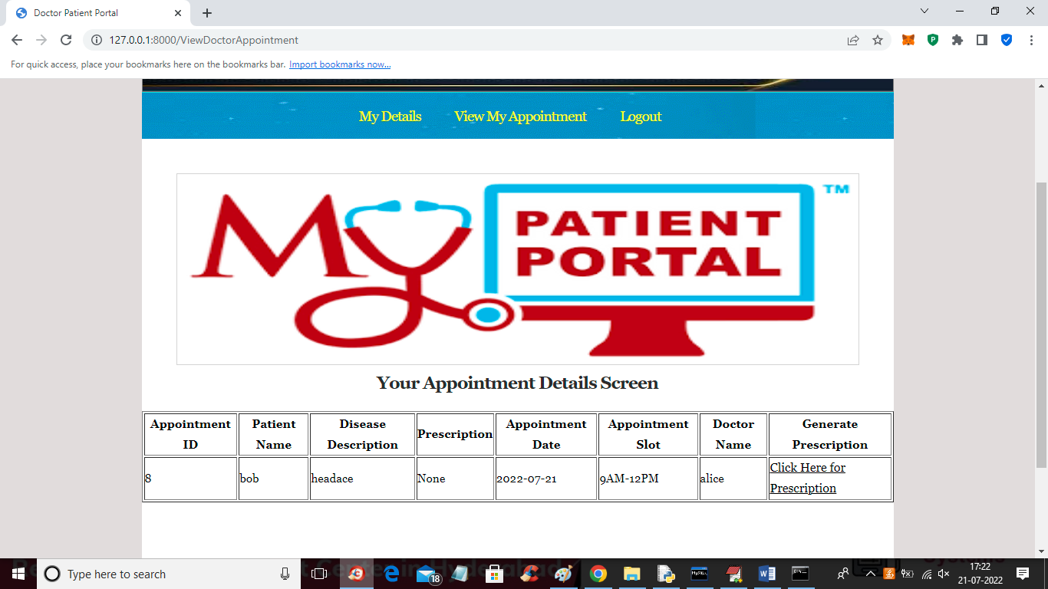

In above screen doctor can click on ‘Click Here for Prescription’ link to generate prescription like below screen

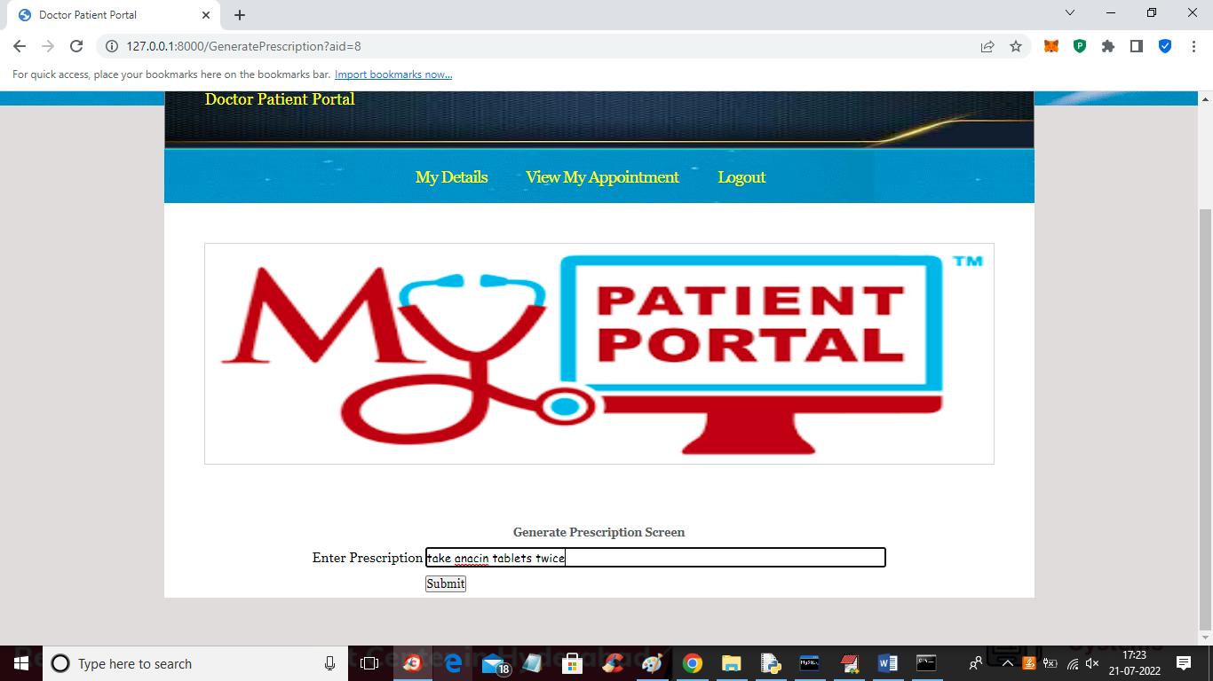

In above screen doctor can enter prescription details and then press button to save prescription and get below output

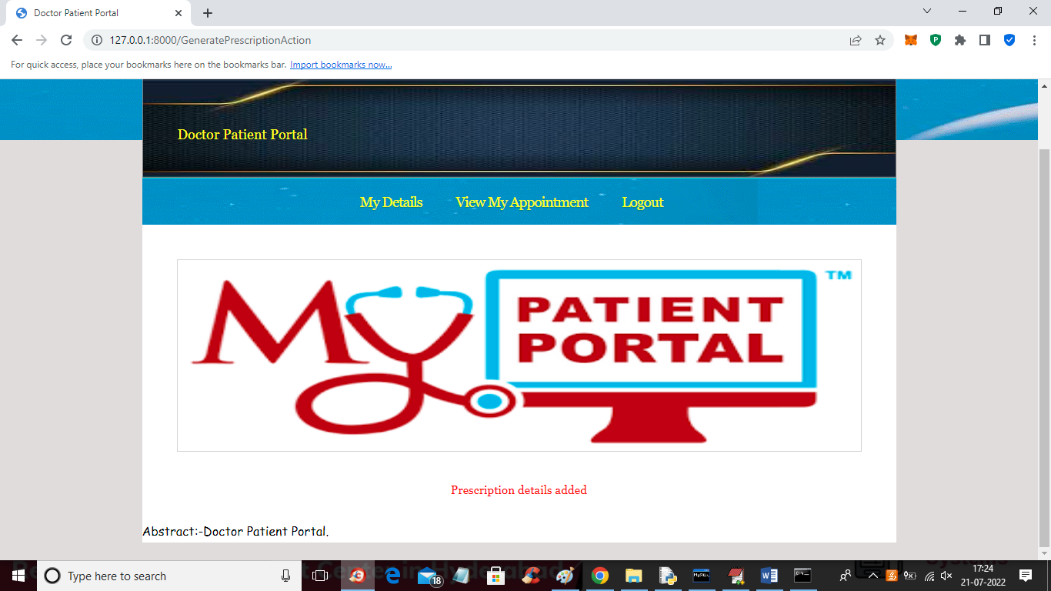

In above screen prescription details added and next time onwards that prescription will display in appointment table for that patient

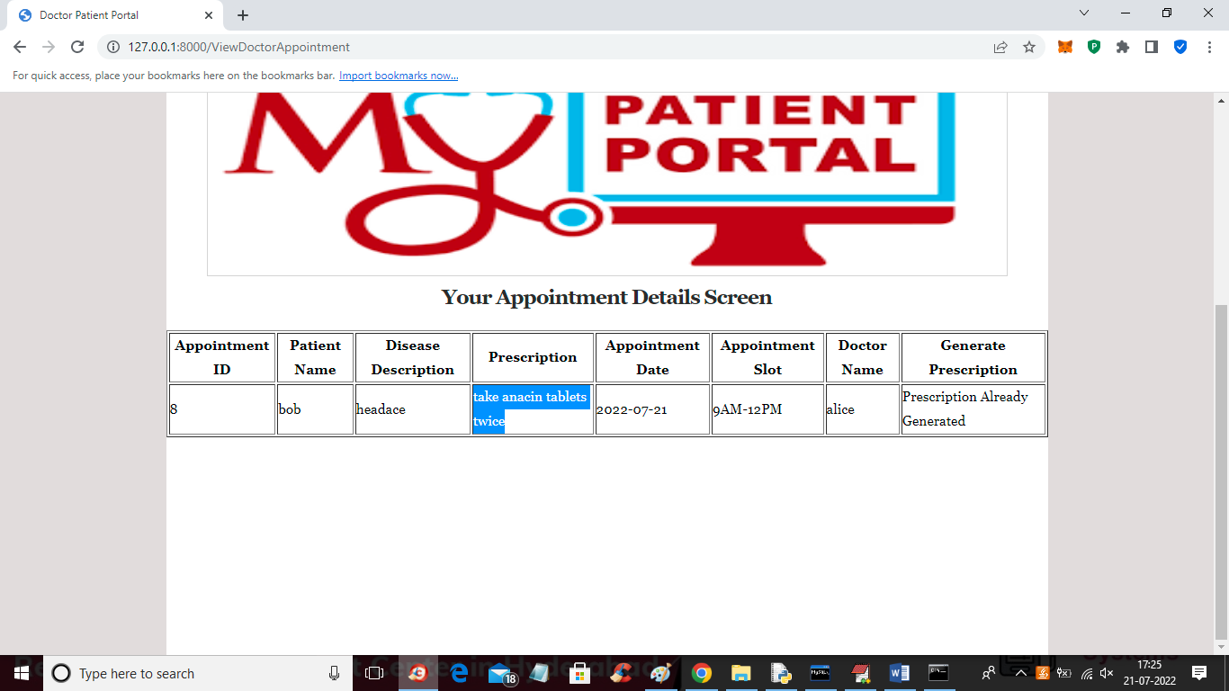

Now in above screen we can see ‘None’ value is replaced with prescription.

Similarly any number of doctors and patients can be added and work with the application